- Order all employees on the basis of the salary they draw.
SELECT f_name, l_name, salary
FROM employee_data
ORDER BY salary;
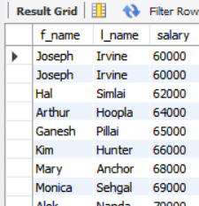
- List all employees in descending order of their years of service.
SELECT f_name, l_name, yos
FROM employee_data
ORDER BY yos DESC;
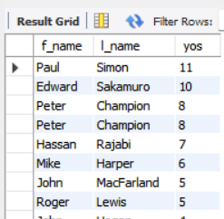

- What does the following statement display?
SELECT id, l_name, title, age
FROM employee_data
ORDER BY title DESC, age ASC;
